Cloud Assignment

First login to the azure account.

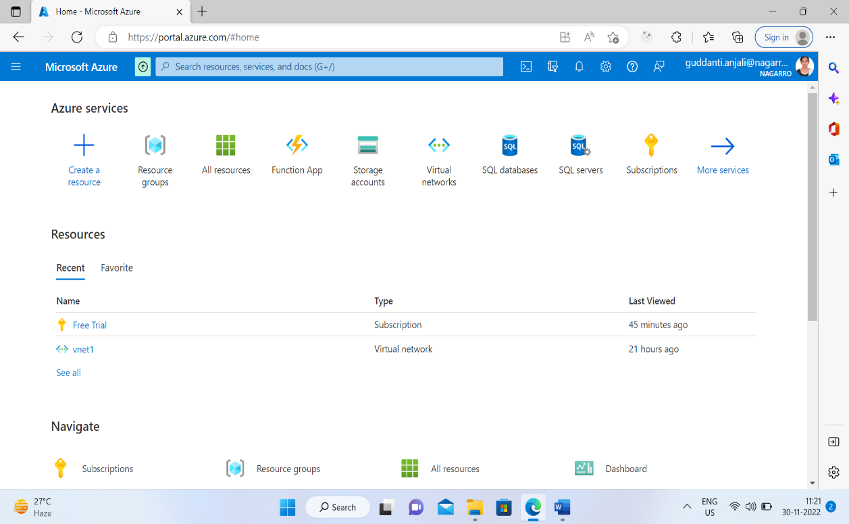

1. Create a virtual network with 2 subnets. Each subnet should have 16 Ips only

Creating resource group

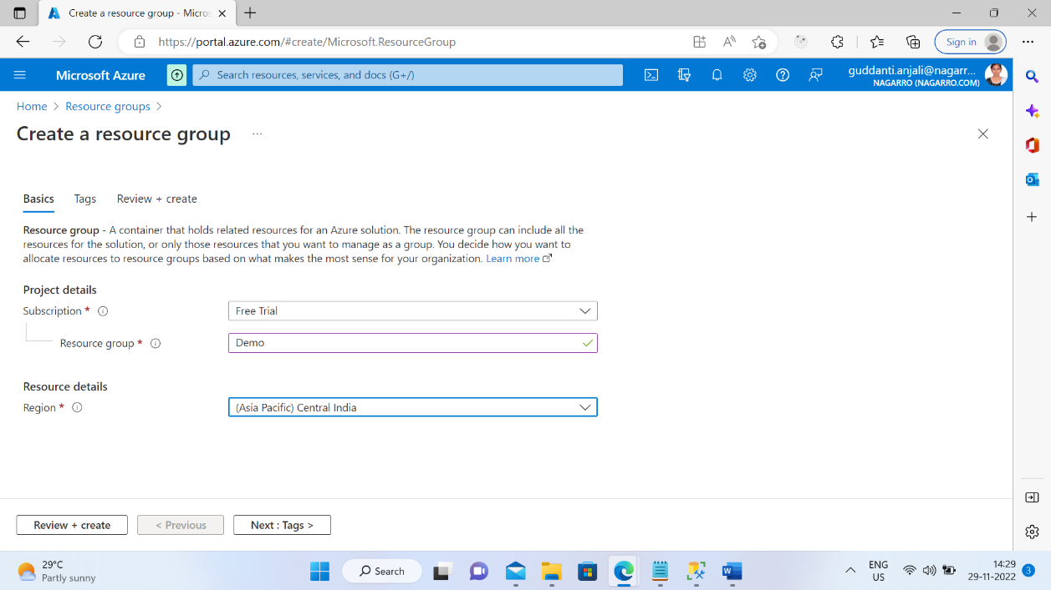

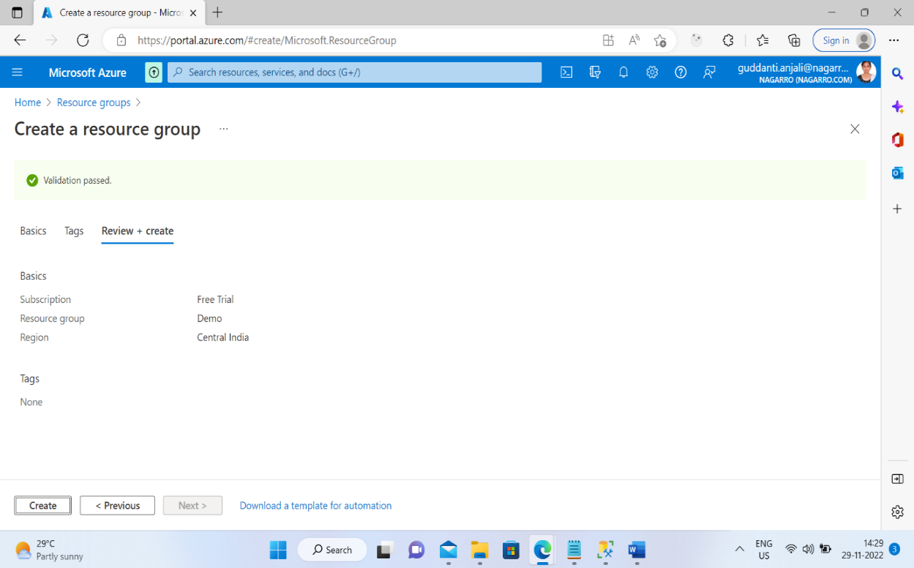

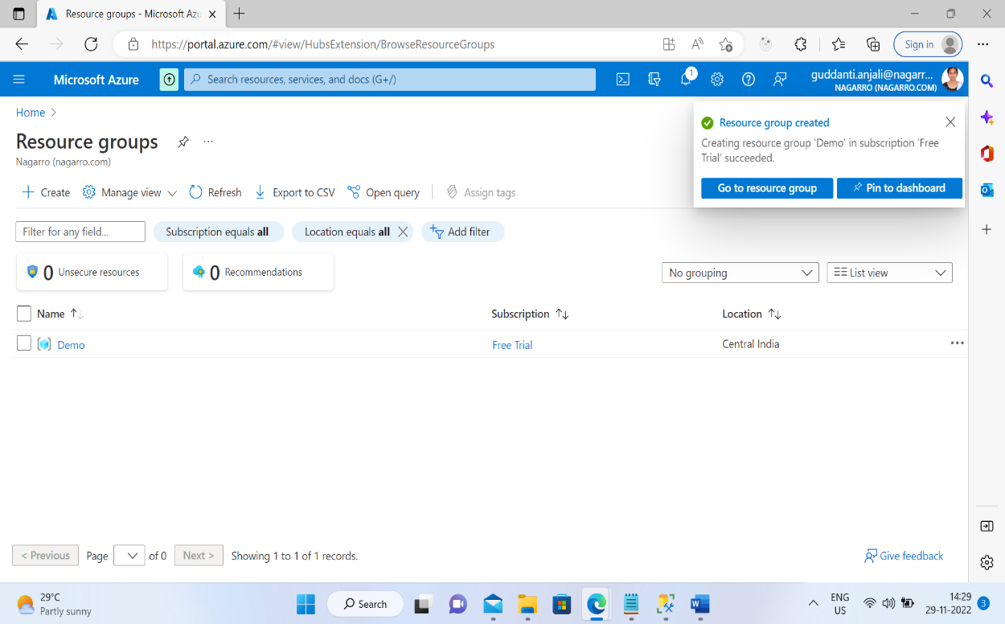

Creating virtual network

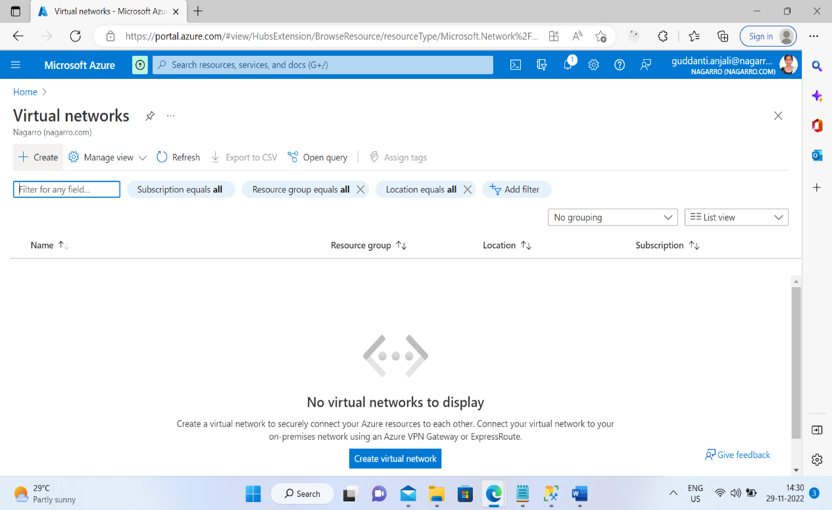

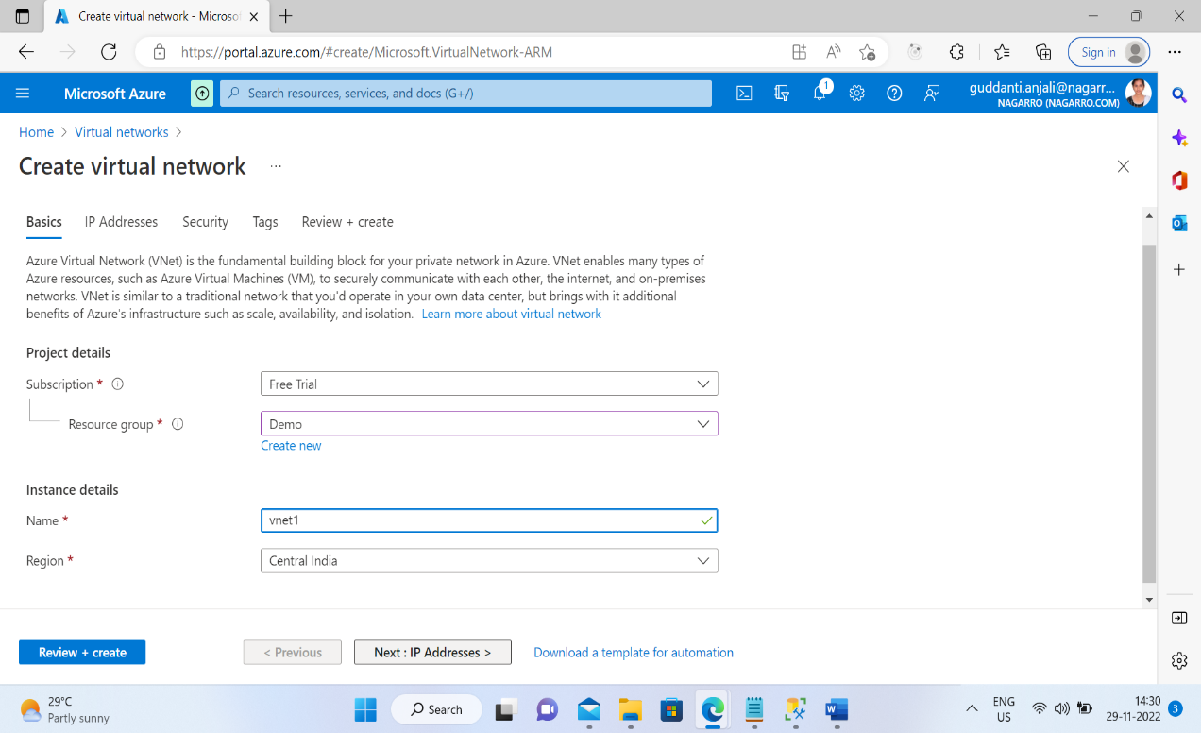

Creating first subnet with 16 Ips

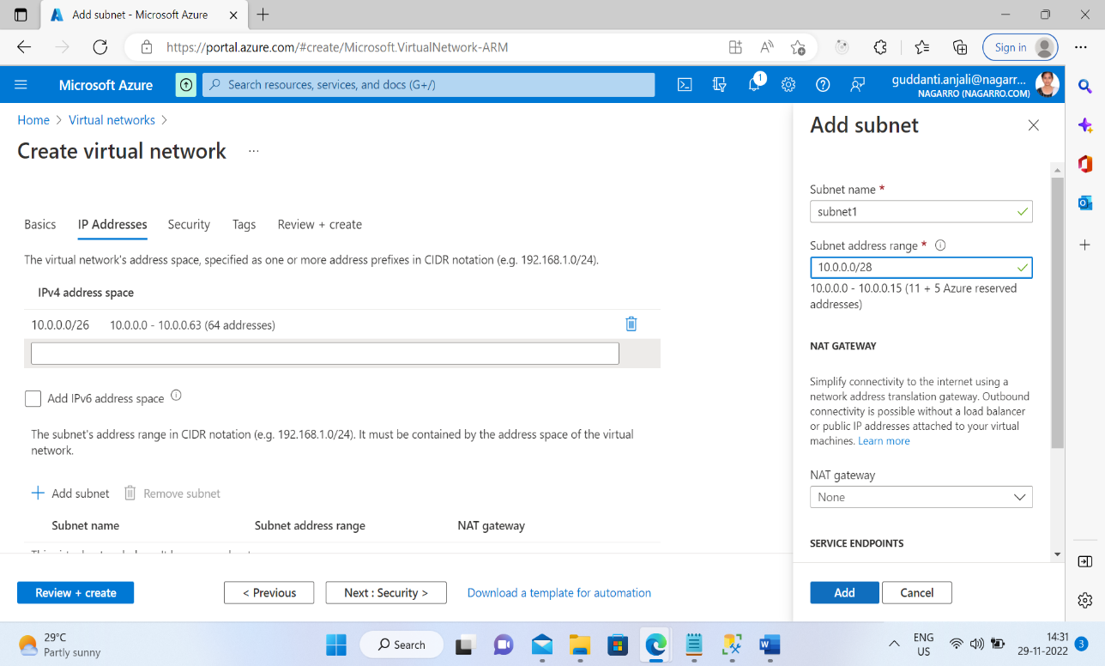

Creating second subnet with16 Ips

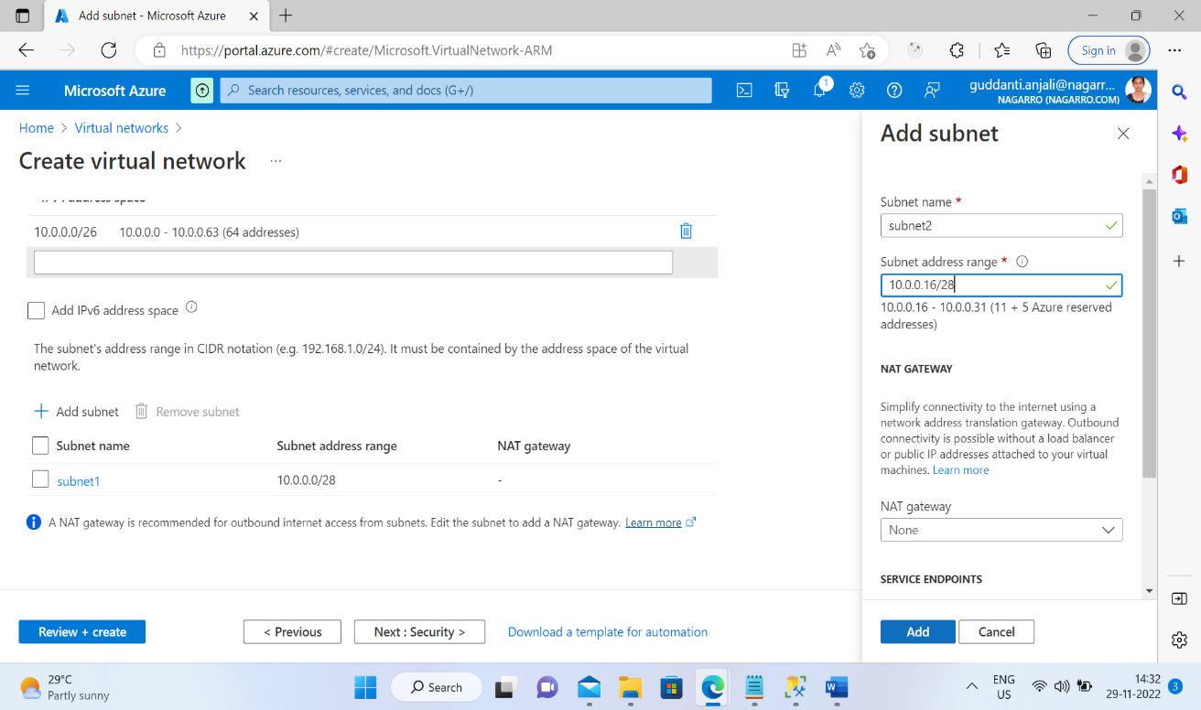

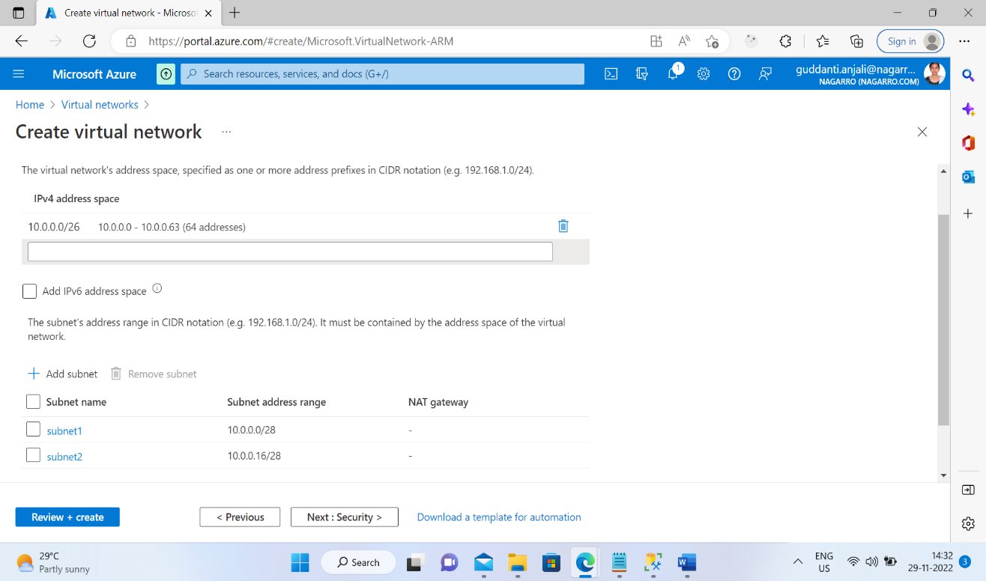

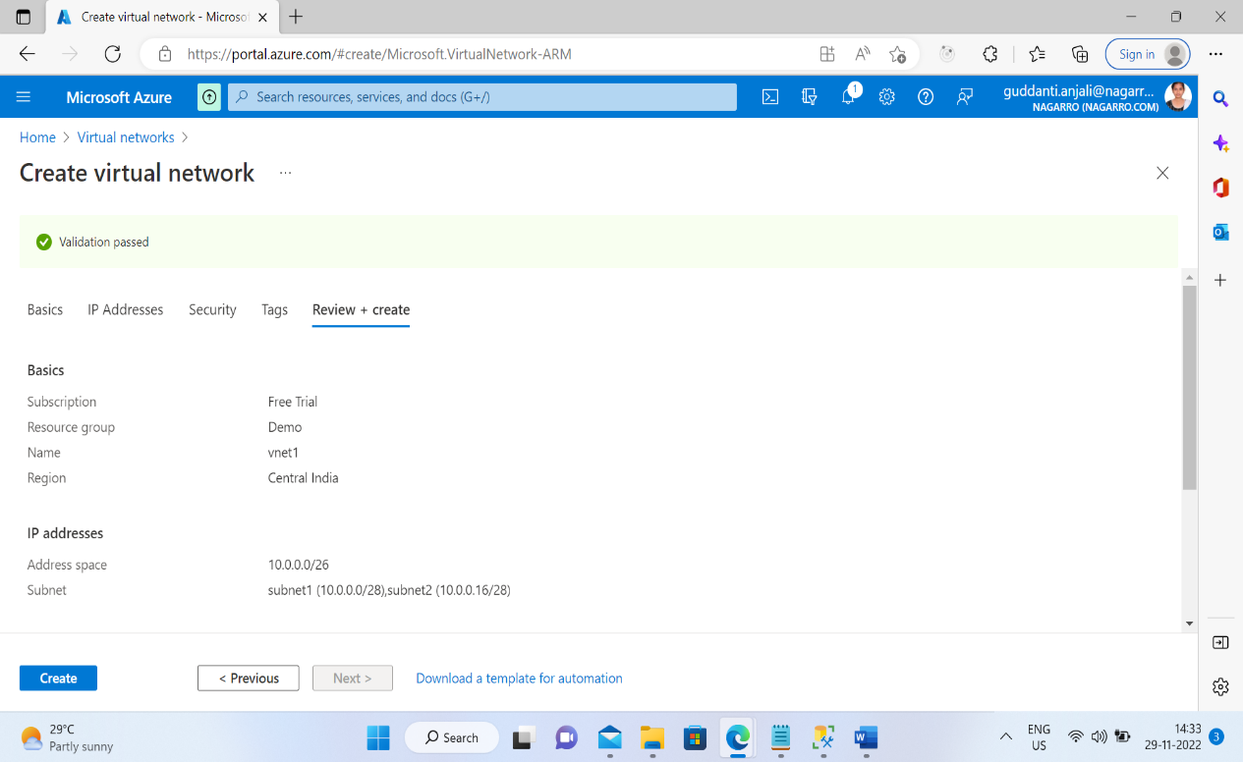

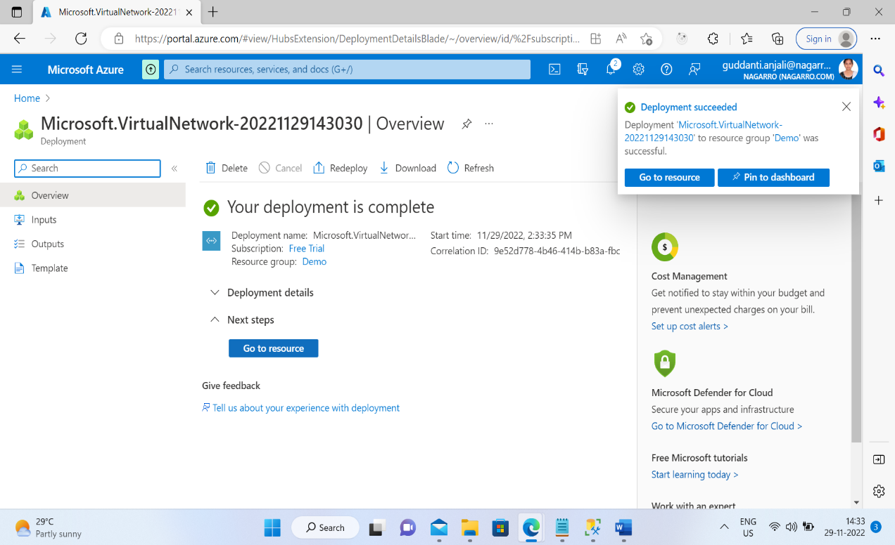

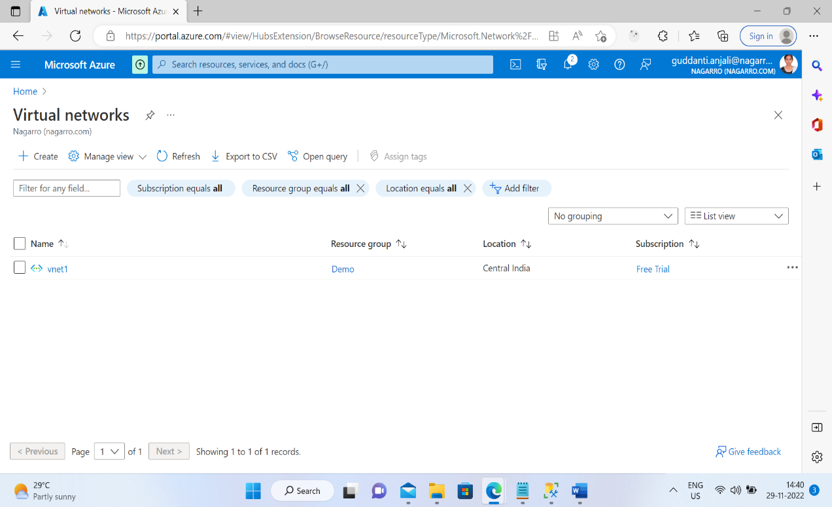

1. Inside one of the subnets, creating  a VM and deploying  MVC application code inside it and it should leverage the database on the cloud .

Search virtual machine in the search bar.

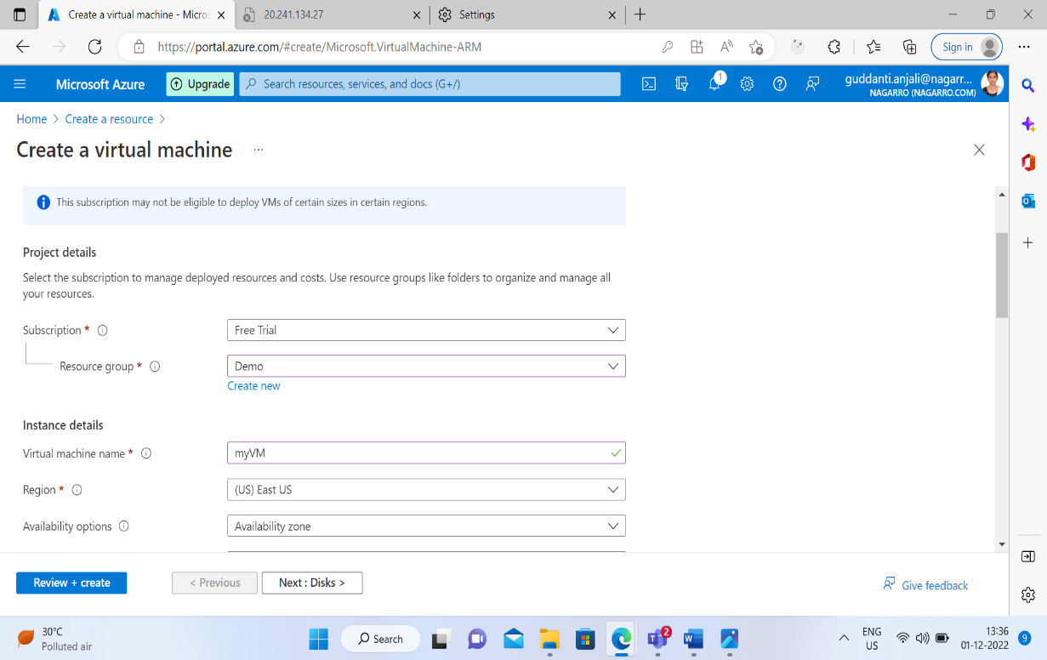

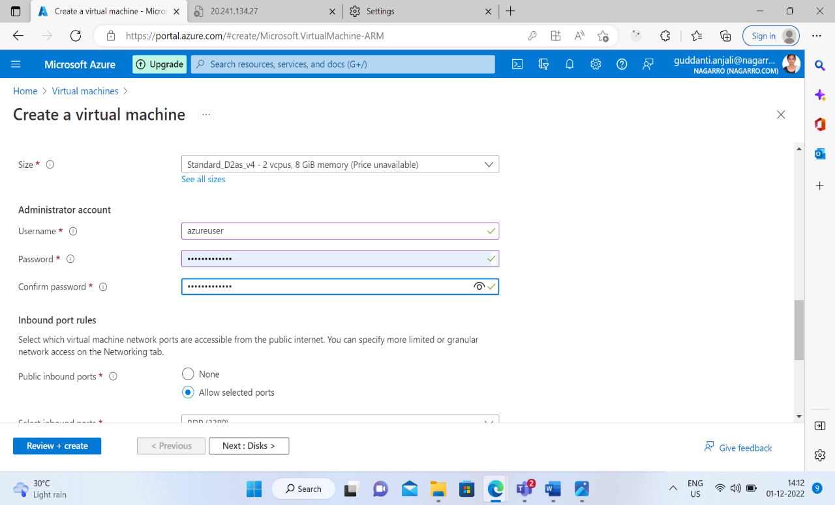

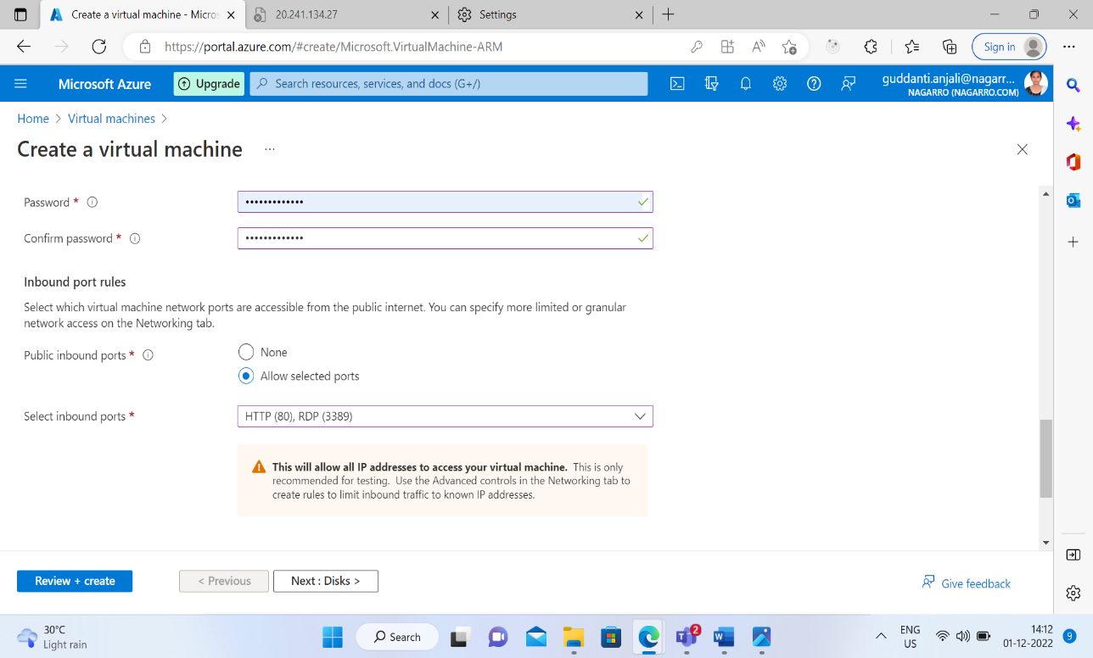

Click on create button

For running the virtual machine on the local computer then download the rdp file after clicking on the connect button.

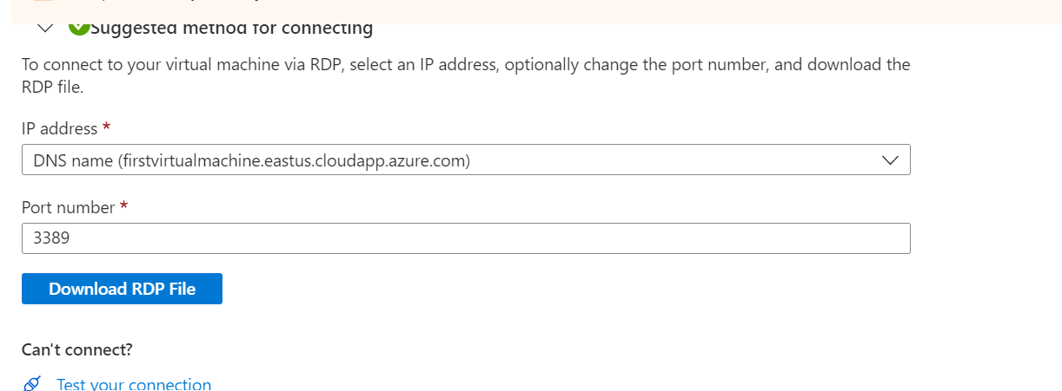

Then after downloading it run the rdp file and then enter the credentials to run the virtual machine

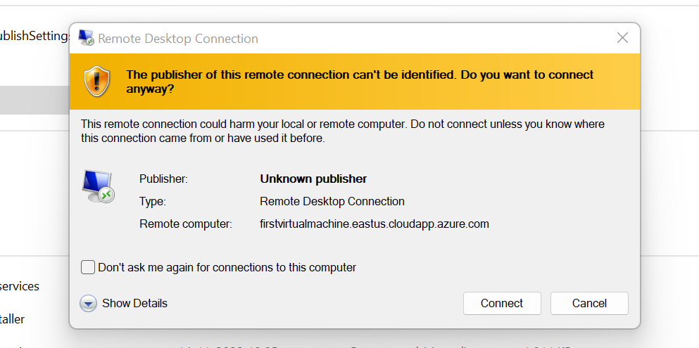

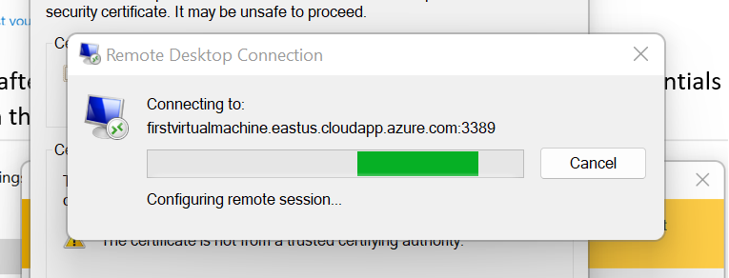

After doing this the virtual machine starts running on your local machine.

For publishing the database on azure first create the webserver on the azure.

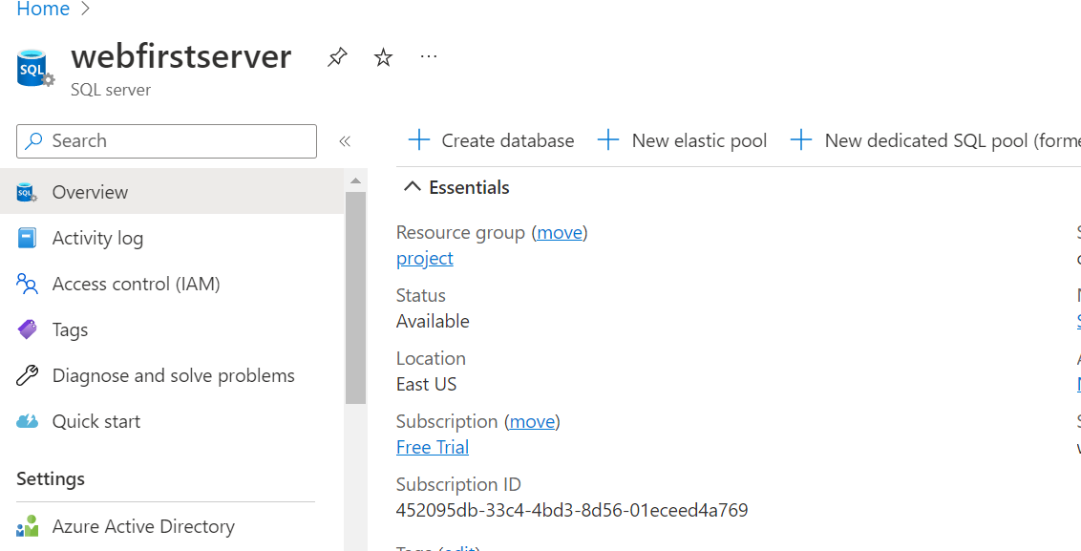

Then open the Microsoft sql server management studio for publishing the database.

Then right click on the database name and then click on deploy database to azure.

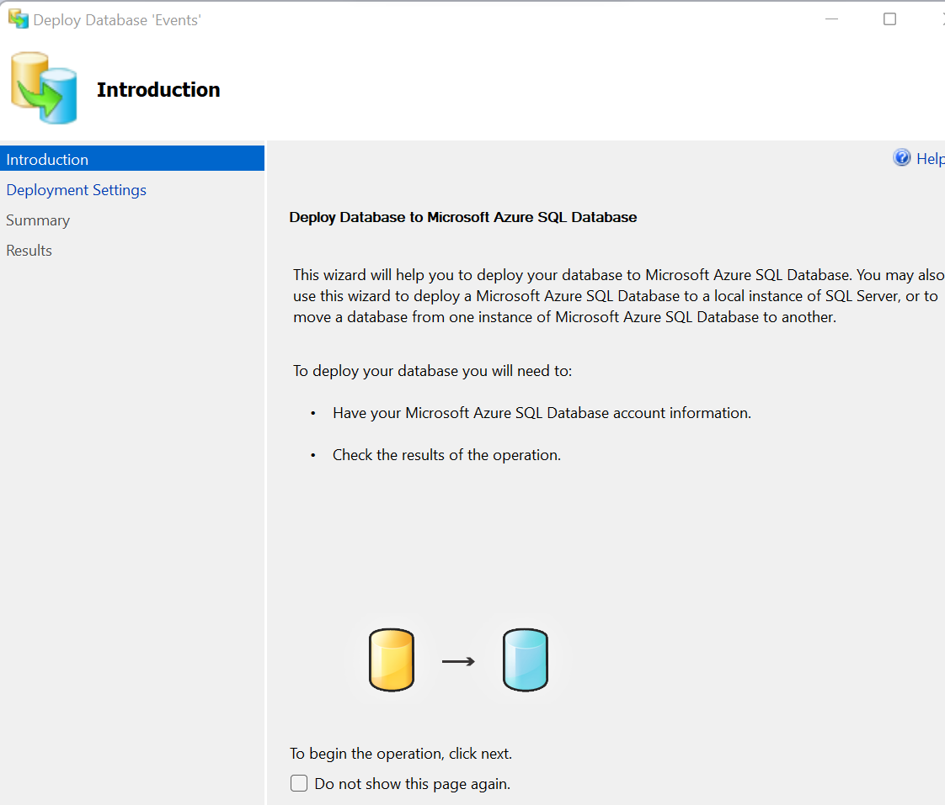

Then click on next and connect to azure web server by providing the credentials.

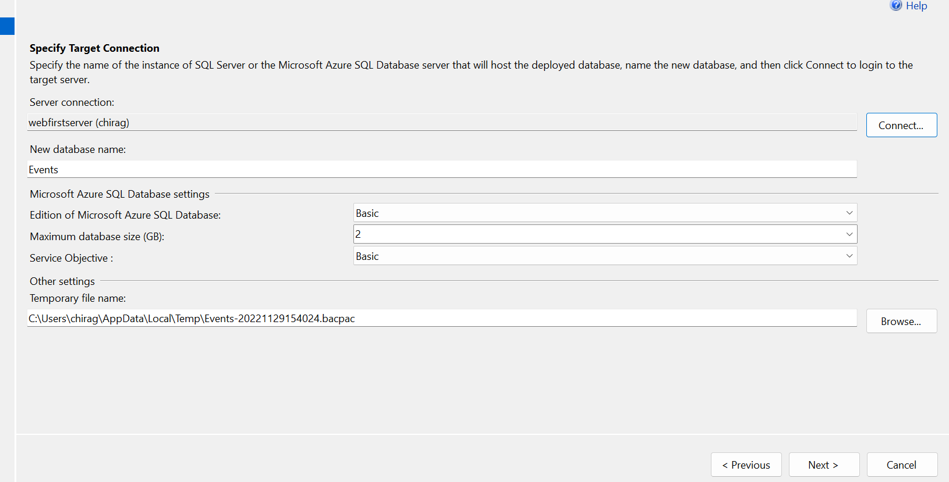

After finishing it open the azure webserver then the database will the there.

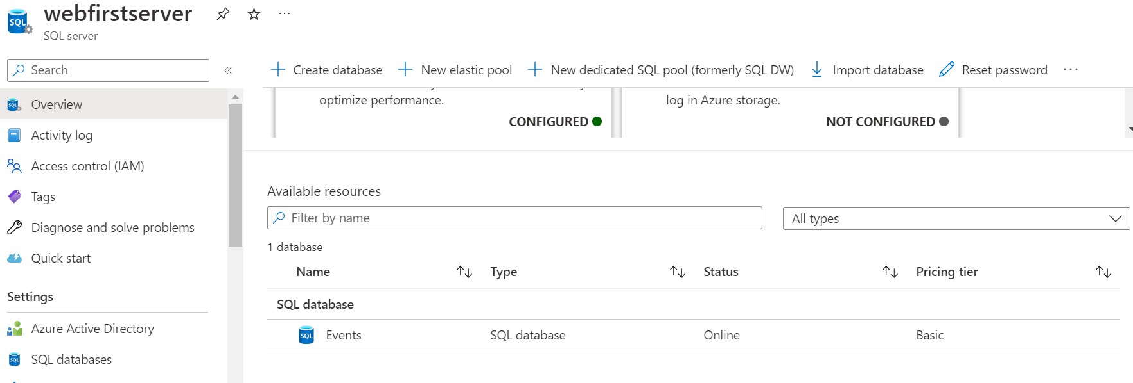

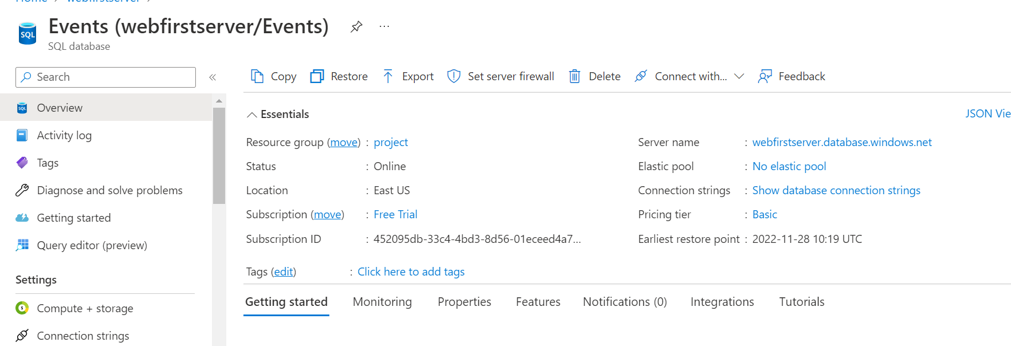

For connecting the application with azure database copy the connection string and then paste it in web.config file of application.

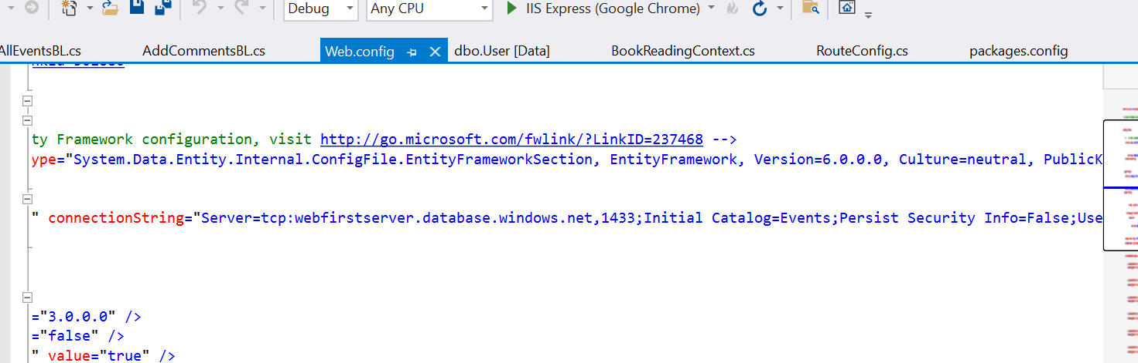

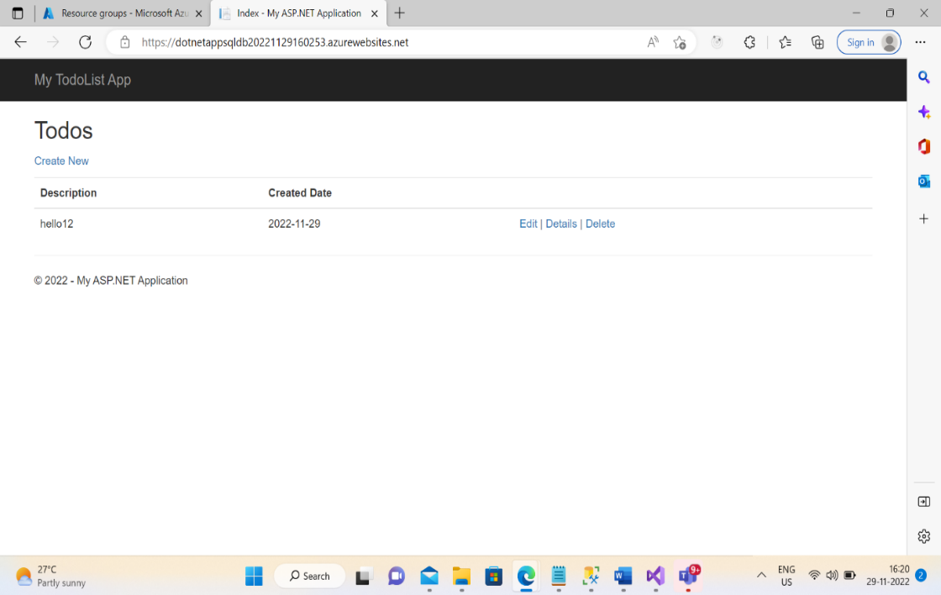

3.Deploy the same MVC application to Azure App Service. It should also leverage the database on the cloud

Running MVC application in local machine

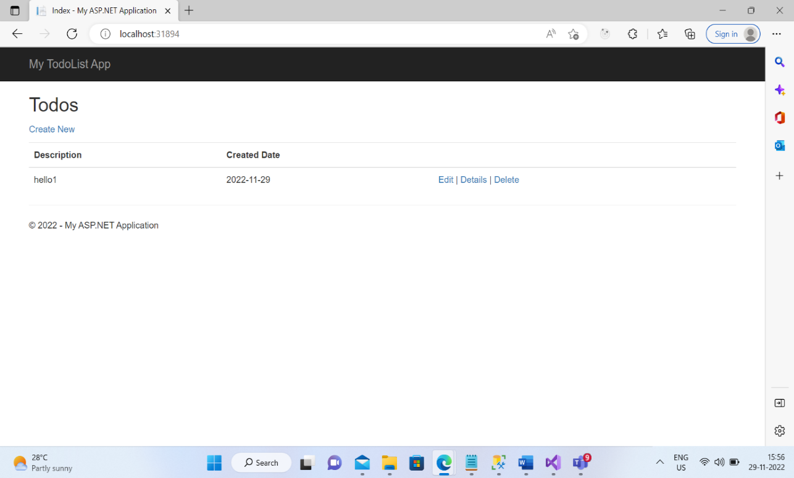 Open the visual studio then right click on the project and then click on the publish button.

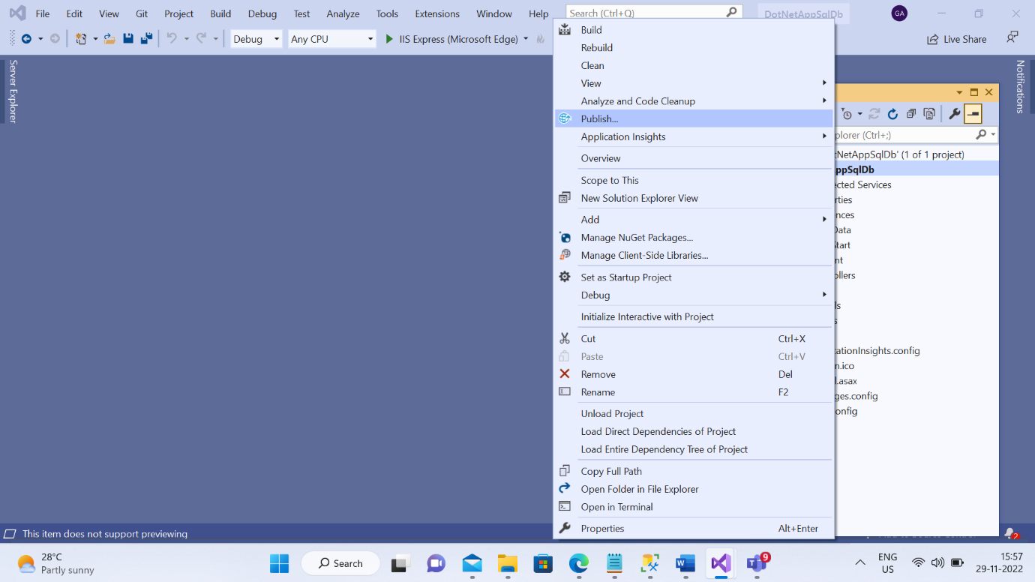

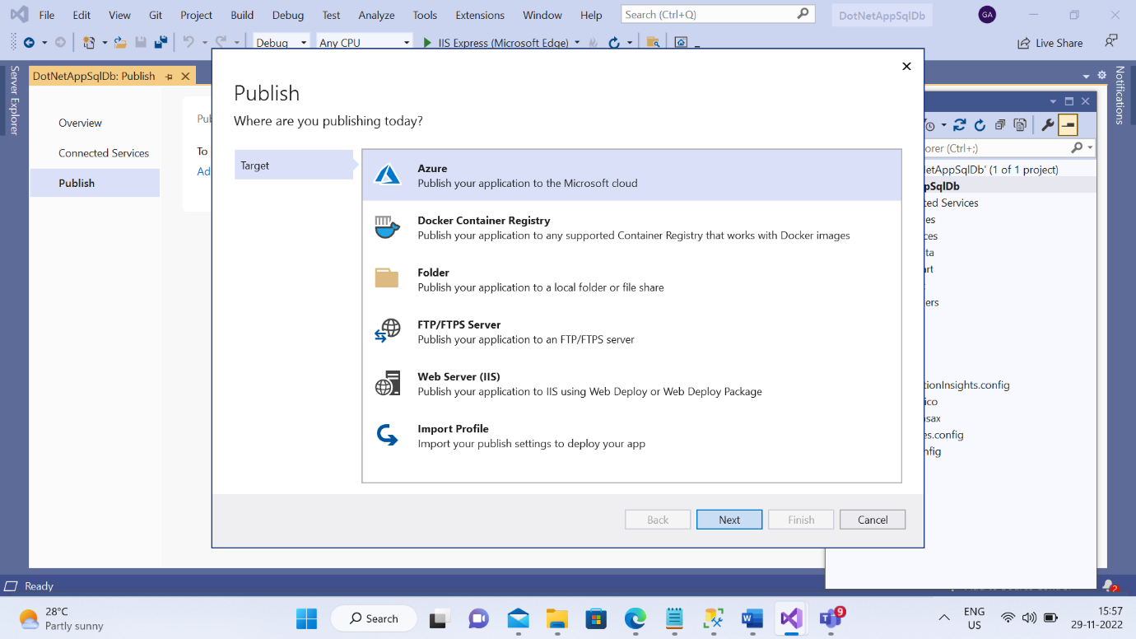

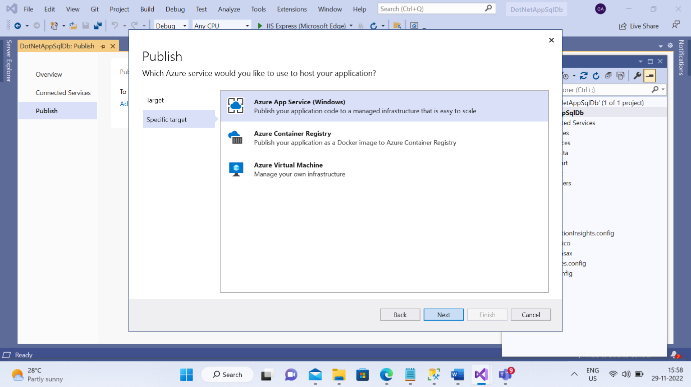

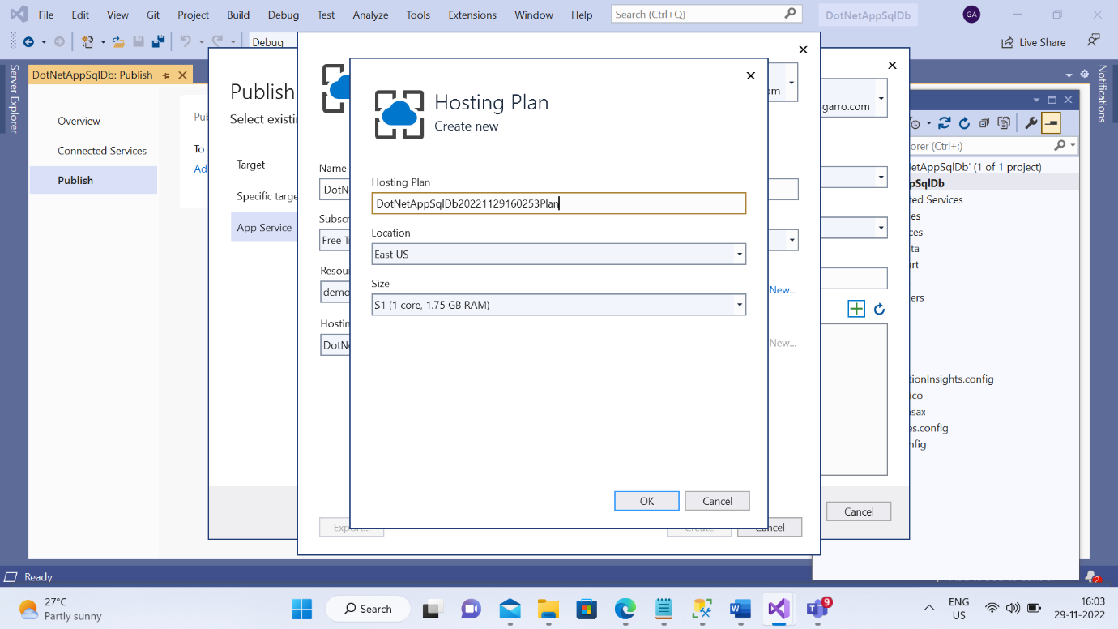

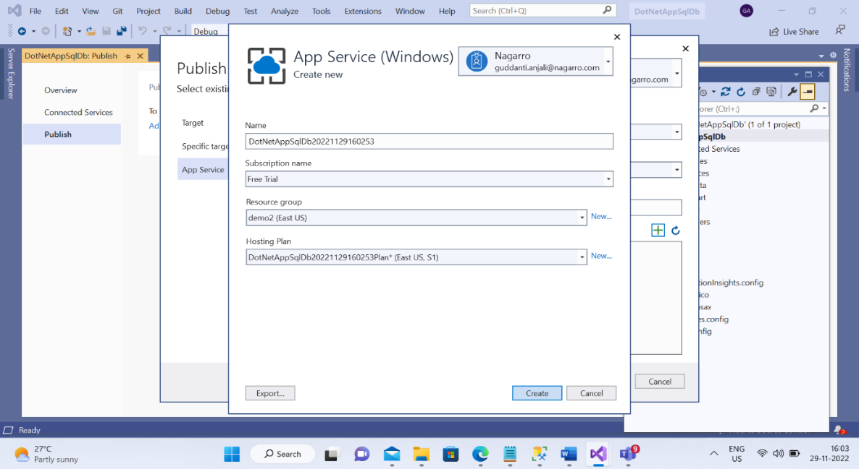

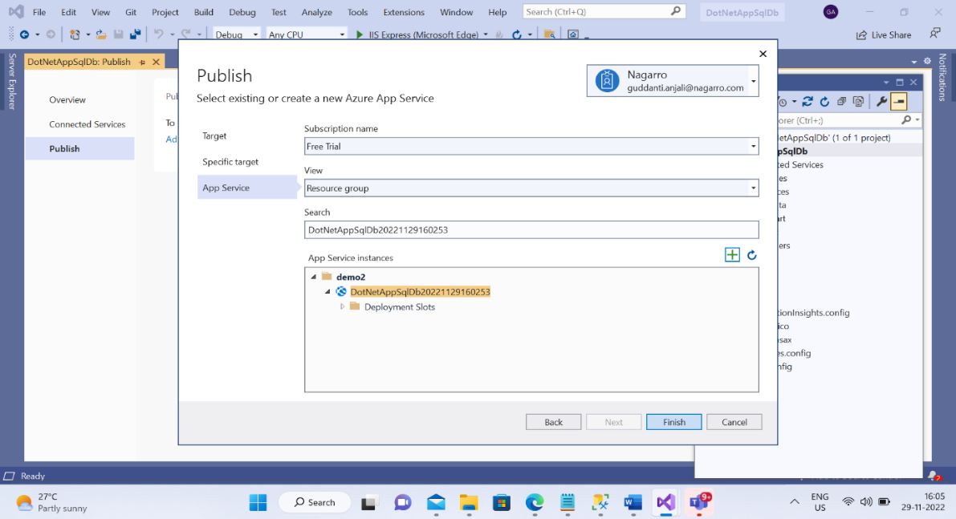

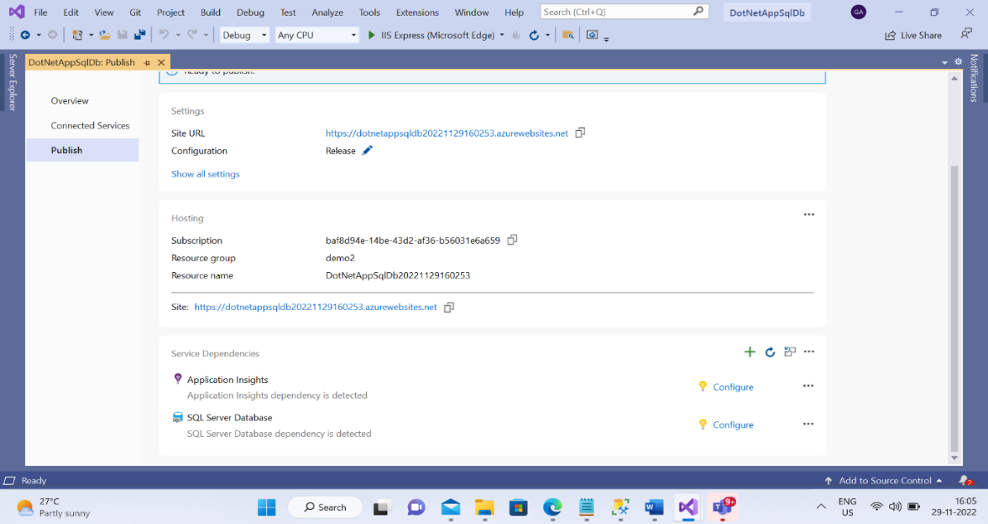

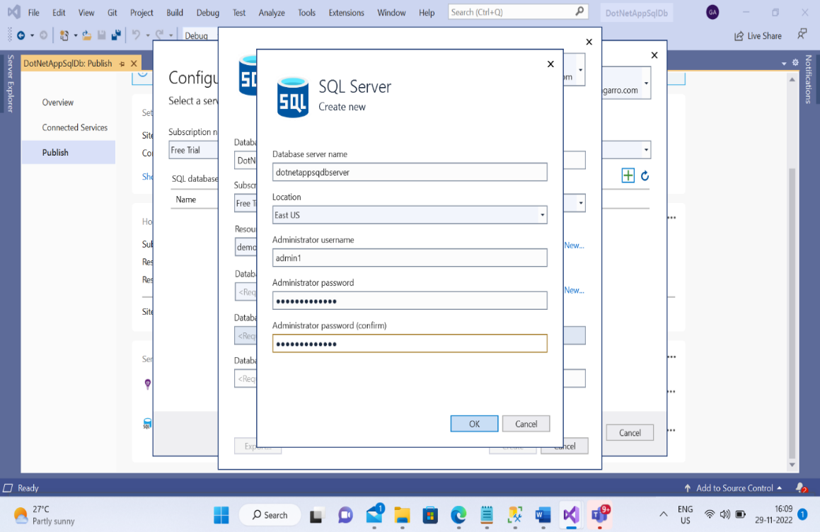

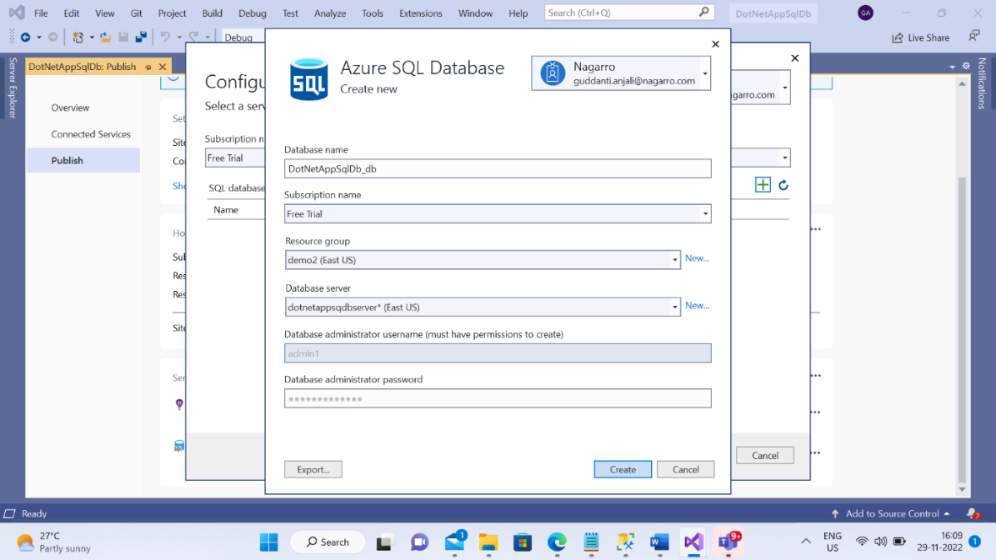

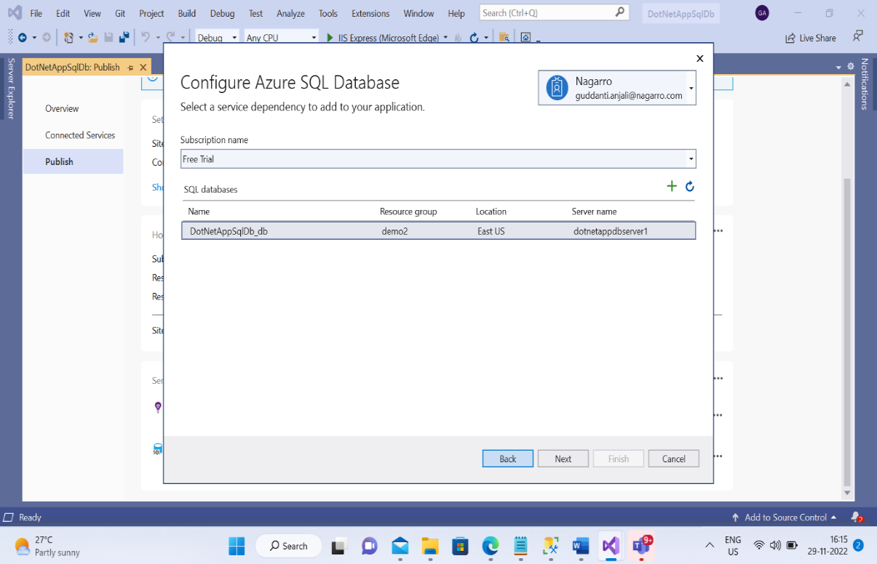

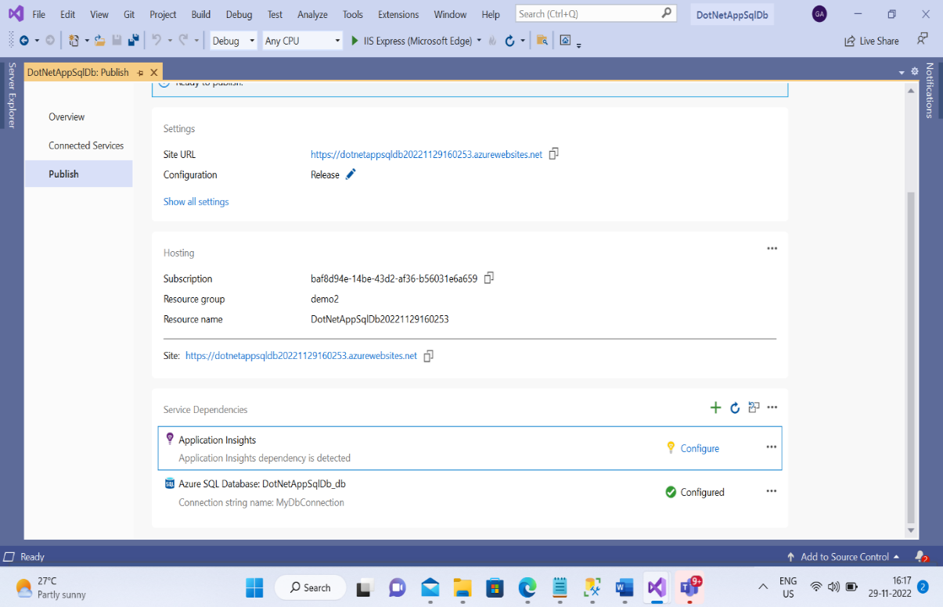



4.Create the AKS cluster (2 nodes, smallest size VM) and deploy any two services on it. Services should be accessible from the internet

Select the Azure Kubernetes Service (AKS)

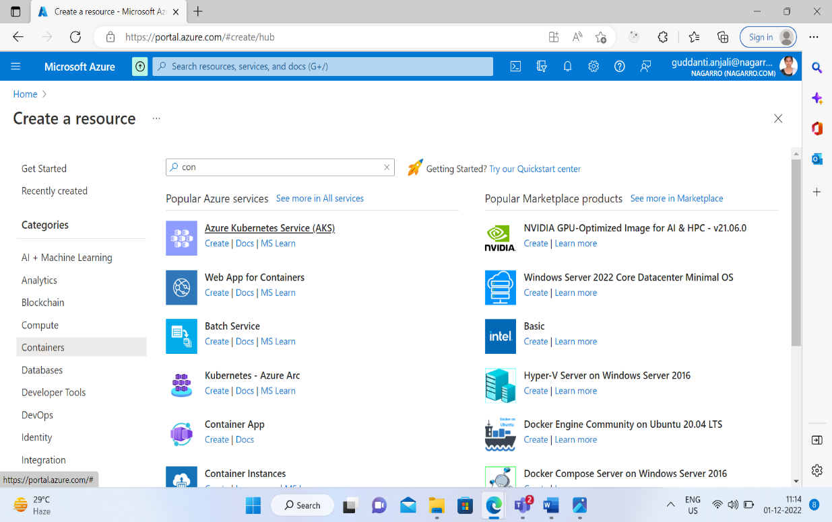

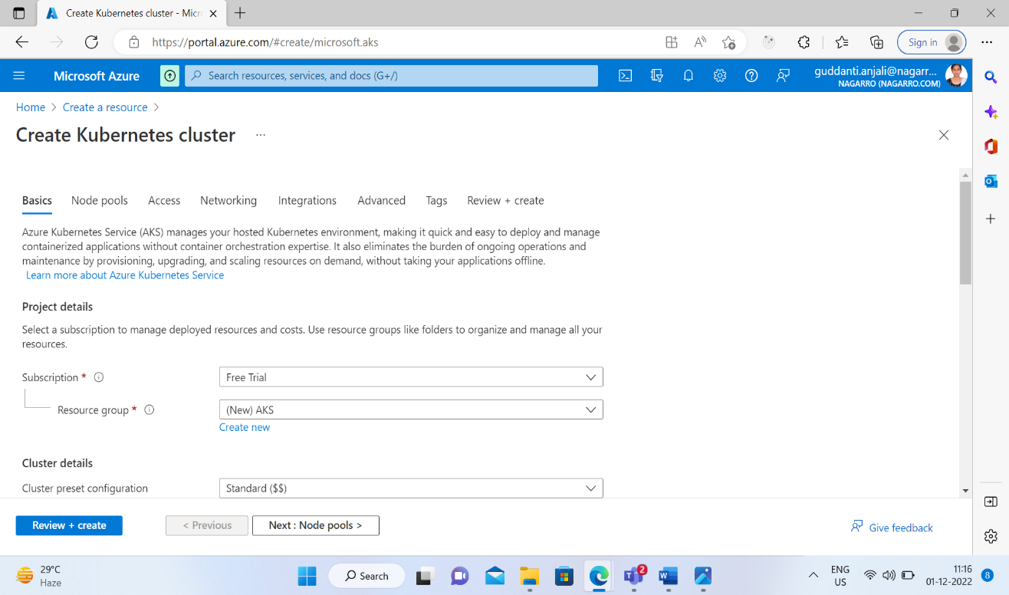

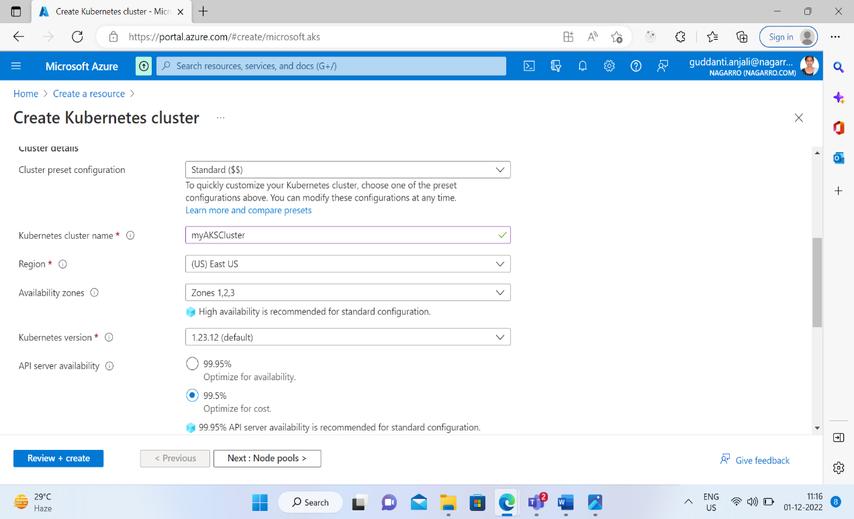

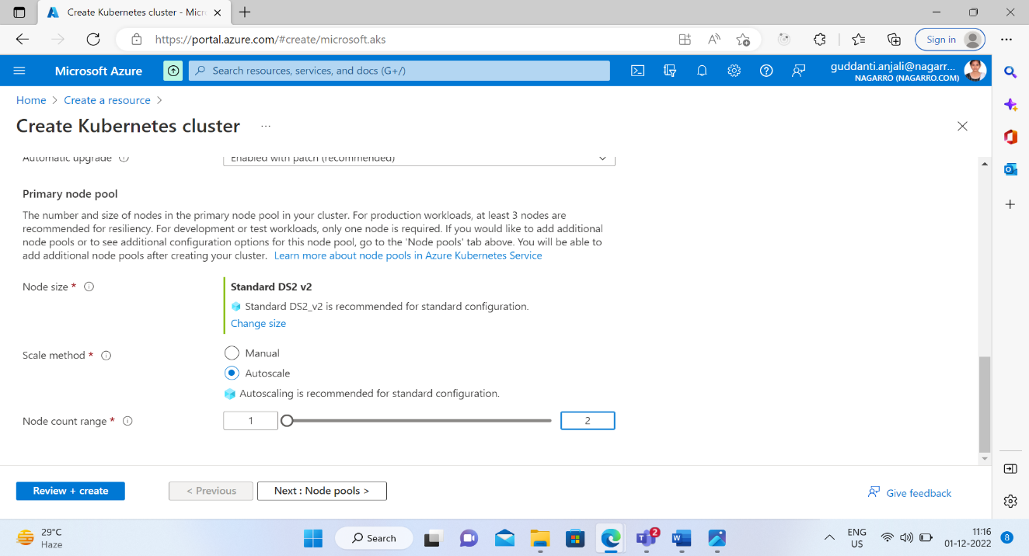

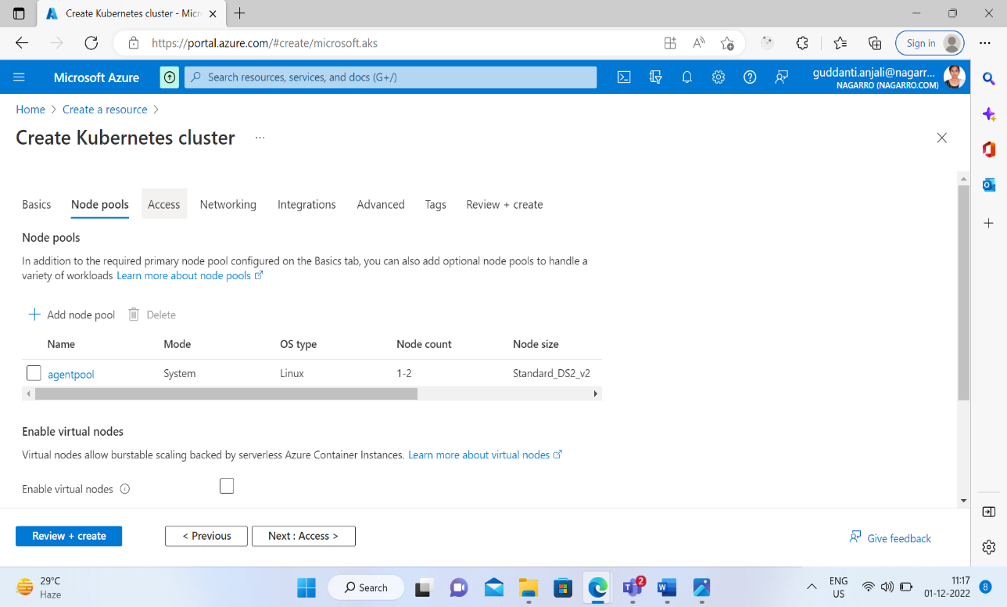

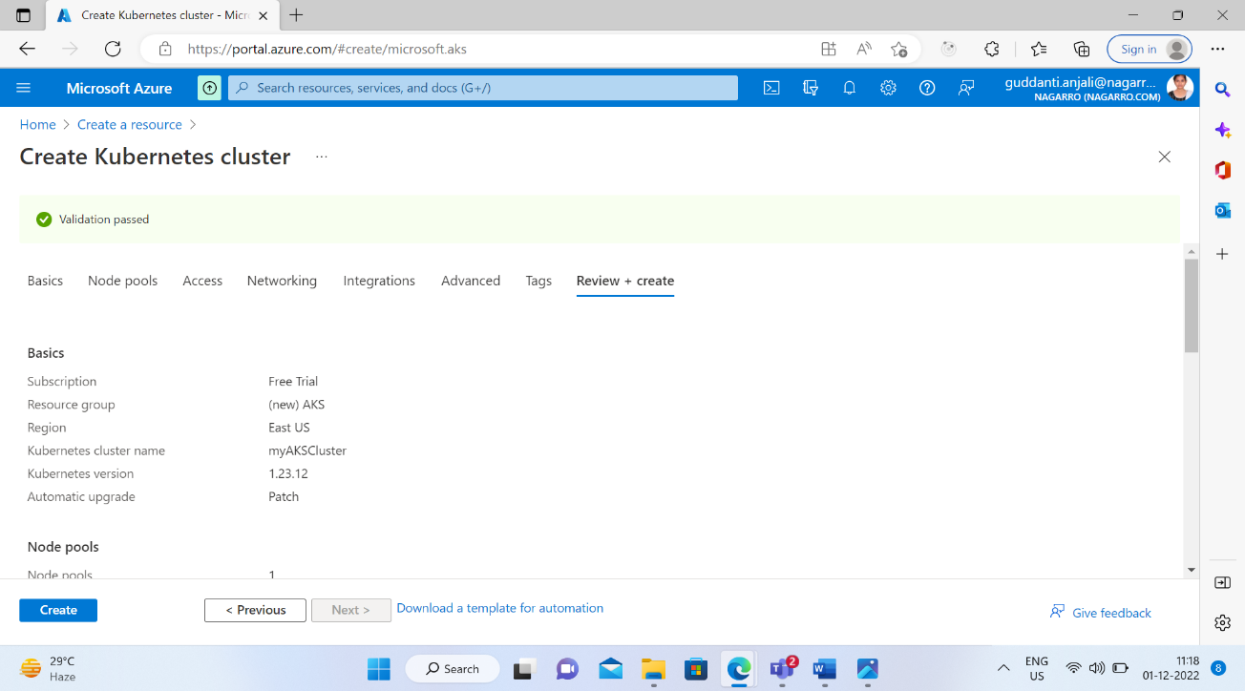

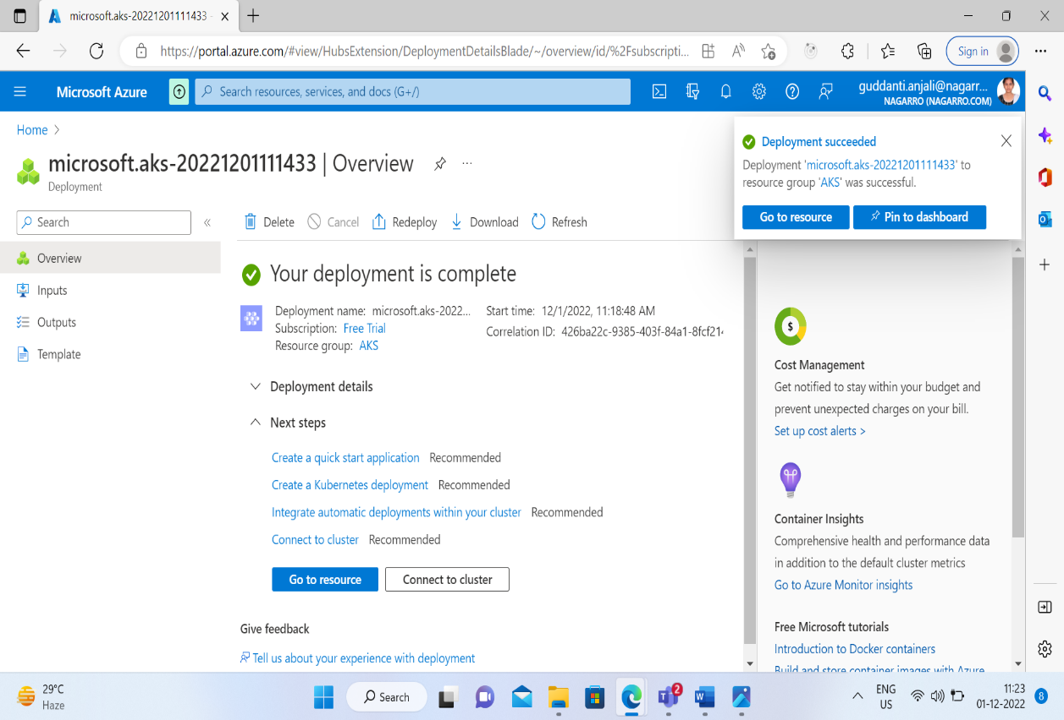

Configuring kubectl to connect Kubernetes cluster using “az aks get-credentials” command

“kubectl get nodes” command return a list of the cluster nodes.

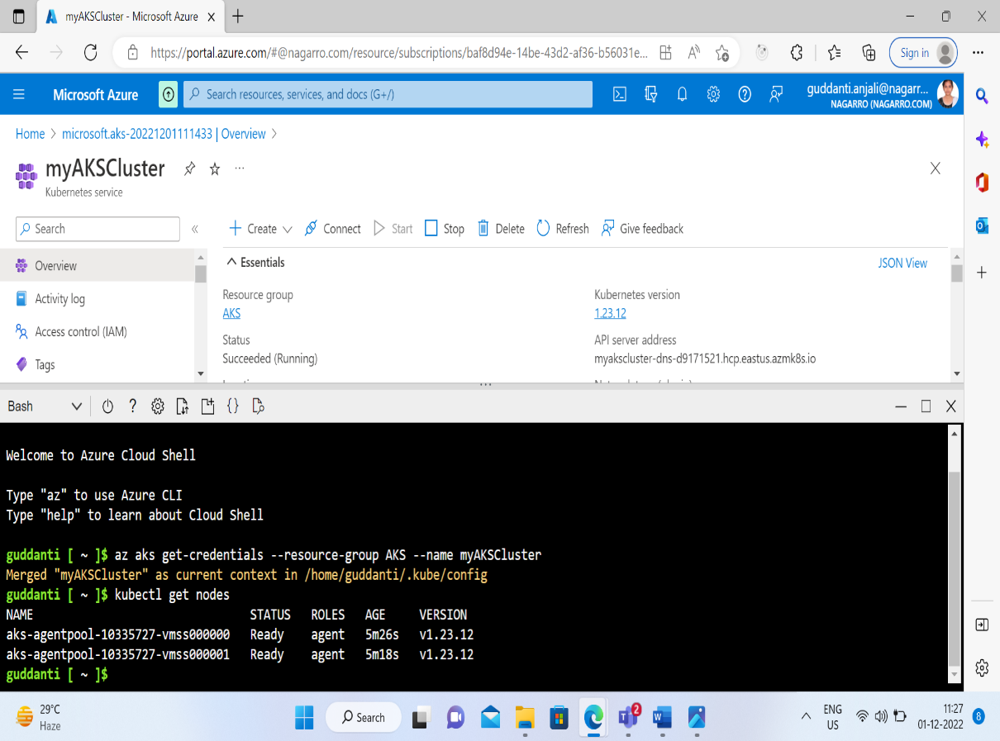

create a file named azure-vote.yaml. Copy in the following YAML definition.

apiVersion: apps/v1

kind: Deployment

metadata:

name: azure-vote-back

spec:

replicas: 1

selector:

matchLabels:

app: azure-vote-back

template:

metadata:

labels:

app: azure-vote-back

spec:

nodeSelector:

"kubernetes.io/os": linux

containers:

- name: azure-vote-back

image: mcr.microsoft.com/oss/bitnami/redis:6.0.8

env:

- name: ALLOW_EMPTY_PASSWORD

value: "yes"

resources:

requests:

cpu: 100m

memory: 128Mi

limits:

cpu: 250m

memory: 256Mi

ports:

- containerPort: 6379

name: redis

---

apiVersion: v1

kind: Service

metadata:

name: azure-vote-back

spec:

ports:

- port: 6379

selector:

app: azure-vote-back

---

apiVersion: apps/v1

kind: Deployment

metadata:

name: azure-vote-front

spec:

replicas: 1

selector:

matchLabels:

app: azure-vote-front

template:

metadata:

labels:

app: azure-vote-front

spec:

nodeSelector:

"kubernetes.io/os": linux

containers:

- name: azure-vote-front

image: mcr.microsoft.com/azuredocs/azure-vote-front:v1

resources:

requests:

cpu: 100m

memory: 128Mi

limits:

cpu: 250m

memory: 256Mi

ports:

- containerPort: 80

env:

- name: REDIS

value: "azure-vote-back"

---

apiVersion: v1

kind: Service

metadata:

name: azure-vote-front

spec:

type: LoadBalancer

ports:

- port: 80

selector:

app: azure-vote-front

Deploying the application using the kubectl apply command.

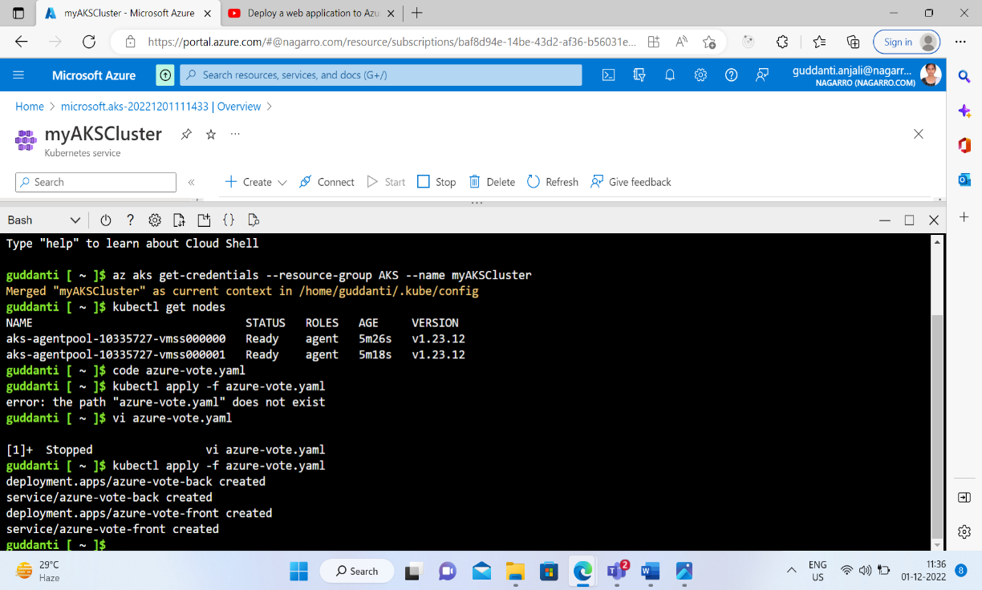

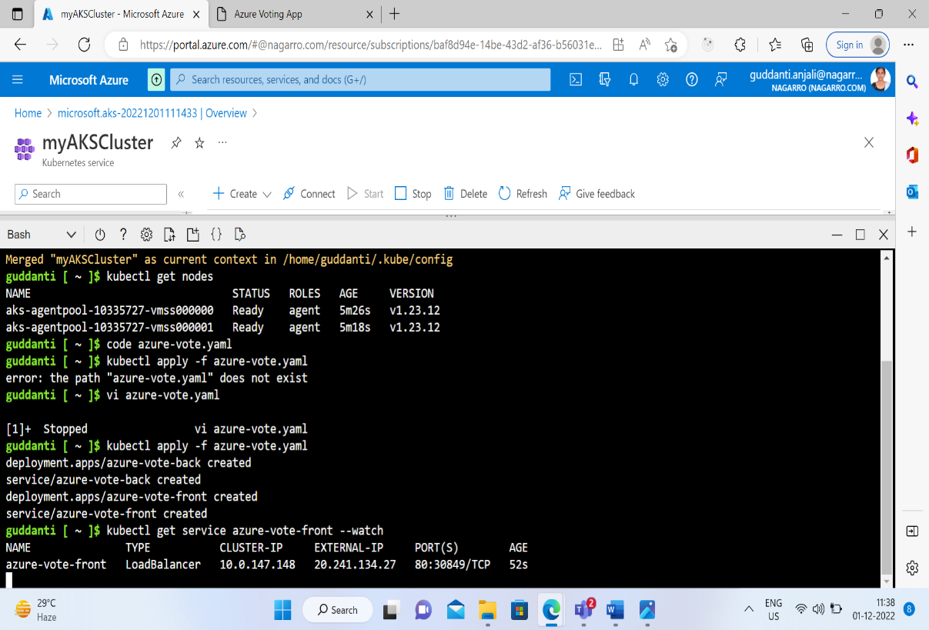

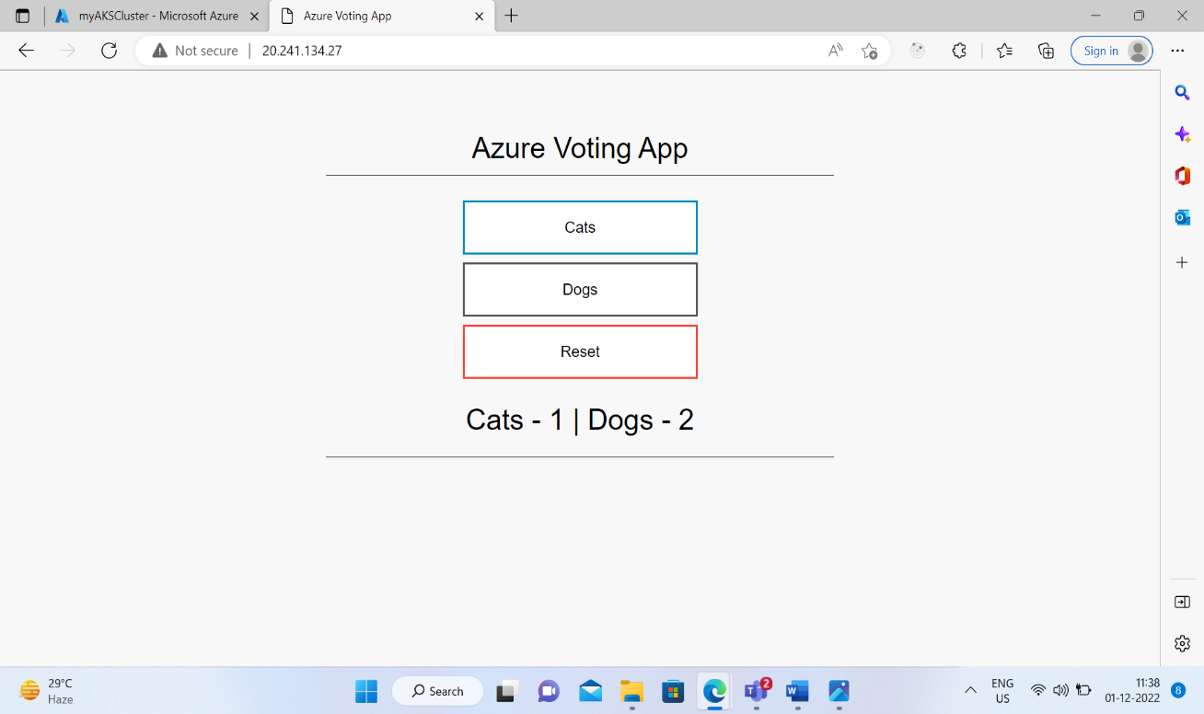

5.Create an Azure function that should trigger as soon as you upload a file in the blob storage. Function should be able to print the name of the file uploaded in the function.

First create azure function project on the visual studio.

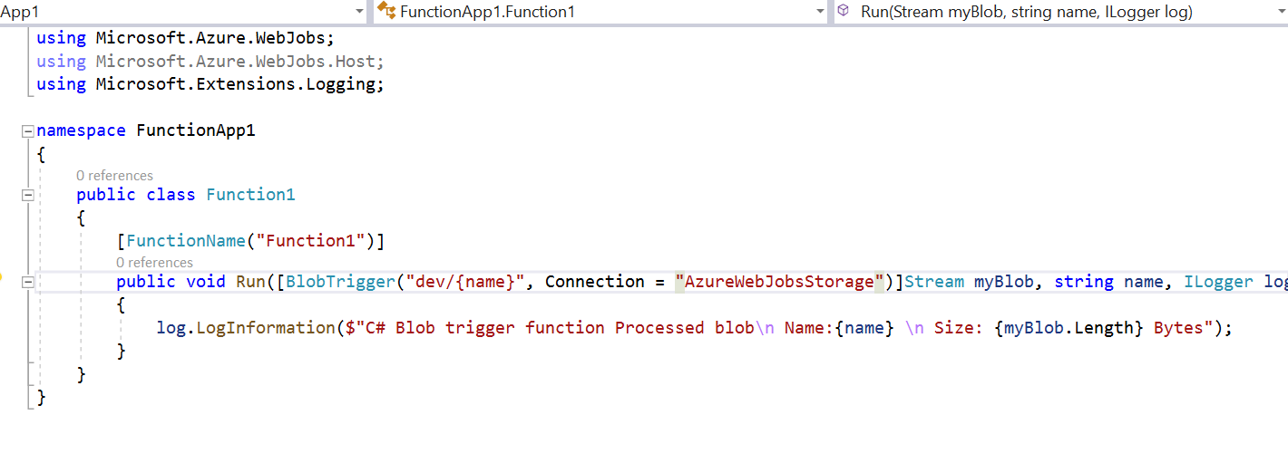

Copy the connection from local.settings.json file and paste it in function argument .

Open the cloud explorer and the create the blob container in which we upload the file .

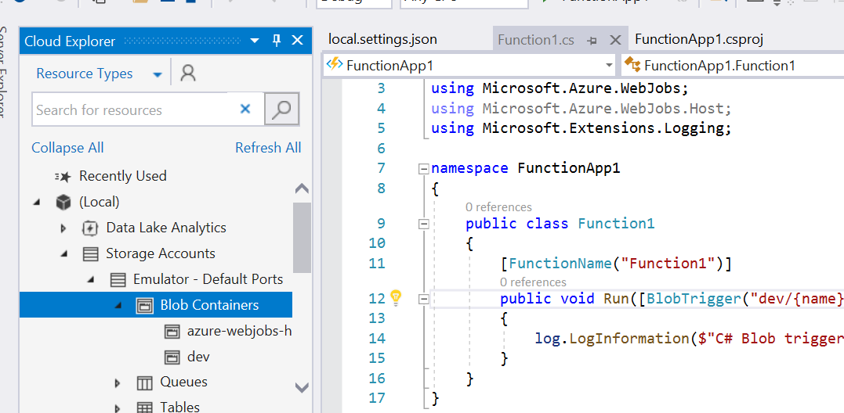

Initially we don’t have any file in blob container so it will show us this.

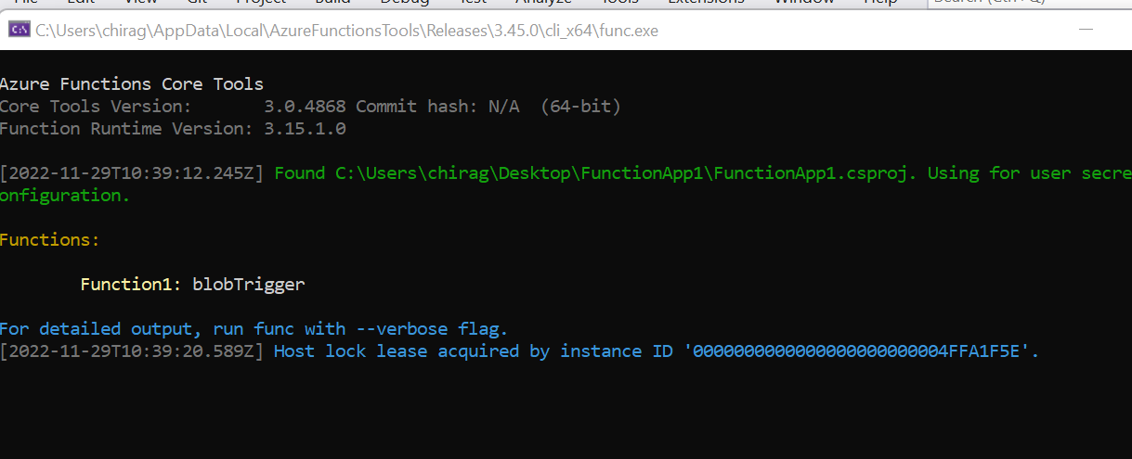

Then upload the file in blob container named K1container.

Then it will show us this.

